
Semester II Exam
2009 Question/Answer Booklet

PHYSICS 12
(Questions marked with a * are for the pre 2010 course)
(Stars have not been placed in the answer key only in the blank question paper)
TIME ALLOWED FOR THIS PAPER

Reading time before commencing work: Ten minutes
Working time for paper: Three hours

MATERIALS REQUIRED/RECOMMENDED FOR THIS PAPER
TO BE PROVIDED BY THE CANDIDATE

Affix Sticker Here
Standard Items
- Pens.
- Pencils.
- Eraser or correction fluid.
- Ruler.

Special Items
- Physical formulae and constants sheet.
- Drawing implements.
- Templates.
- Calculators satisfying the conditions set by the Curriculum Council.

TO BE PROVIDED BY THE SUPERVISOR
This Question/Answer Booklet.
Physical Formulae and Constants sheet.

IMPORTANT NOTE TO CANDIDATES

No other items may be taken into the examination room.

It is your responsibility to ensure that you do not have any unauthorised notes or other items of a non-personal nature in the examination room. Please check carefully and if you have any unauthorised material with you hand it in to the supervisor BEFORE reading any further.

 | Short Answer | Problem Solving | Comprehension | Total
Marks | /60 | /100 | /40 | /200
% | /30 | /50 | /20 | /100

STRUCTURE OF THE PAPER

Section | No of  questions | No of marks  out of 200 | Proportion of  exam total
A: Short Answers | 15 | 60 | 30%
B: Problem Solving | 8 | 100 | 50%
C: Comprehension & Interpretation | 2 | 40 | 20%

INSTRUCTIONS TO CANDIDATES

Write your answers in the spaces provided beneath each question in sections A and B
The value of each question in section A is four marks.

Note that (where appropriate) answers should be given numerically and they should be evaluated and not left in fractional or radical form. Give all numerical answers to three significant figures except in the cases for which estimates are required.

Questions containing specific instructions to show working should be answered with a complete, logical, clear sequence of reasoning showing how the final answer was arrived at; correct answers which do not show working out will not be awarded full marks.

Questions containing the instruction estimate may give insufficient numerical data for their solution. Candidates should provide appropriate figures to enable an approximate solution to be obtained.

Candidates should remember that when descriptive answers are required, they should be used to display understanding of the aims and objectives of the Physics 12 course. A descriptive answer, which addresses the context of a question without displaying an understanding of physics principles, will not attract marks.

Despite an incorrect final result, credit may be obtained for method and working, provided these are clearly and legibly set out.
SECTION A : Short Answers - 60 Marks (30%)

Attempt ALL 15 questions in this section.
Show all working out. (4 marks each)

1. A stunt driver takes his motorcycle around a vertical loop-the-loop of diameter 9.80 m. What minimum speed must the cycle have at the top point of the loop in order to stay on the track?
(4 marks)

2. Explain with aid of force diagrams, why an athlete leans into a curve when running round a bend in a track.
(4 marks)

3. A body mass of mass “m” rests on a plane surface inclined at an angle X° to the horizontal. Find an expression for the friction force parallel to the plane in terms of weight.
(4 marks)

X ⁰

m

4. The diagram shows a person using a walking frame. Very old people, or people weakened by illness, often use these frames as aids. Imagine you are the physiotherapist who first designed the walking frame. Give an account of its purpose and use from a physics perspective.
(4 marks)

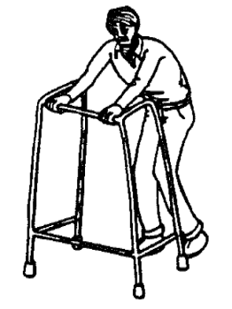

5. A gymnast hangs from two rings fixed to a wall as shown in the diagram below. He is stationary. His arms make an angle of 20.0 ⁰ with the horizontal. The weight of his body is 800 N. Estimate the effective tension in one of his arms.
(4 marks)

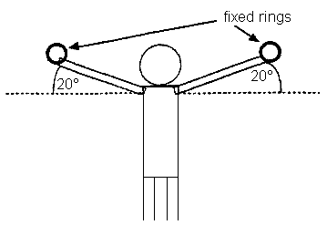

6. A uniform bridge has a mass of 450 tonnes and is supported by two concrete piers (A & B) 80.0 m apart. A truck of mass 40.0 tonnes is parked 15.0 m from pier A.

A
B
Bridge
Piers

a) Which pier exerts the greatest force?
(1 mark)

b) Calculate the force exerted by this pier.
(3 marks)

*7. Samples of hardwood and cast iron have the following approximate tensile and compressive strengths.

Material | Approximate compressive strength (MN m⁻²) | Approximate tensile strength (MN m⁻²)
Hardwood | 50 | 100
Cast Iron | 500 | 150

Beams in bridges and buildings are often subjected to forces like those shown by the arrows in the diagram below. When cast iron beams are used like this, they are often designed with a cross-section similar to that shown below. The lower part of the beam is much thicker than the upper part. Explain why it is better for the lower part of the beam to be made thicker than the top part. Your answer should include reference to the table above.
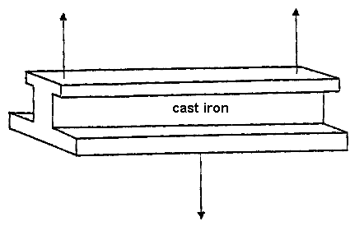
Cross section of beam
Side View

(4 marks)

8. Below is a cross section through the earth showing the paths followed by seismic waves generated by an earthquake at the focus.
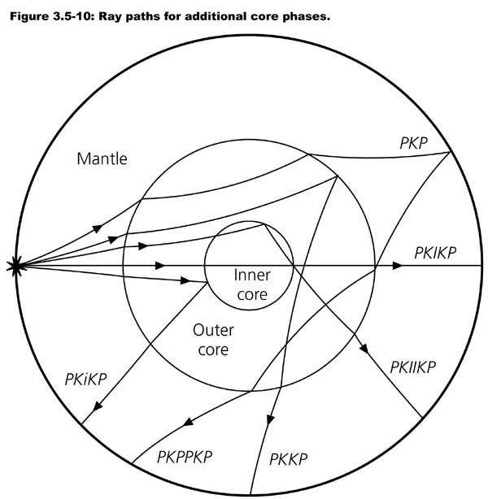
Focus
A
B
C
a) What type of wave is an earthquake?

b) Name the wave process happening at A.

c) Name the wave process happening at B.

d) Name the wave process happening at C.

(4 marks)

9. The thickest string of a guitar is tuned to the musical note E which is 82.5Hz.
The string next to it is tuned to the note A at 110 Hz.

a) Draw the standing (stationary) wave of the E string vibrating at its fourth harmonic.
(1 mark)

- - - - - - - - - - - - - - - - - - - - - - - - - - - - - - - - - - - - - -- - - - - - - - - - - - - - - - - -

b) Draw the standing (stationary) wave of the A string vibrating at its third harmonic.
(1 mark)

- - - - - - - - - - - - - - - - - - - - - - - - - - - - - - - - - - - - - -- - - - - - - - - - - - - - - - - -

c) What frequencies would you hear if both of these harmonics were played together?
(2 marks)

10. Match each of the following situations with a type of spectra by completing the table below.
(4 marks)
Situation | Absorption  Or  Emission | Line, Band or Continuous
An ionic salt dissolved in water is sprayed as a solution into a Bunsen burner flame.
Carbon dioxide at low pressure in a discharge tube collides with high speed electrons.
A Tungsten filament in a light globe glows when electricity is passed through it.
Fraunhoffer lines are observed when light from the sun which has passed through the earth’s atmosphere is examined.

11. When violet light of wavelength 4286 Ǻ is shone onto the surface of a solar cell, electrons leave the surface of the cell with a velocity of 4.67 x 10⁵ m s⁻¹. These electrons are collected (and accumulate on) a metal fly wire mesh positioned 1.00 cm above the surface of the solar cell. The surface of the cell and the fly wire are in a vacuum.
UV
electron
Metal (Positive)
Mesh (Negative)
Vacuum

What is the ionization energy of the solar cell surface in electron volts?
(4 marks)

12 . Two identical bar magnets A and B are each dropped down a tube. A is dropped down a copper tube and B is dropped down a plastic tube. If the time it takes for the bar magnets to fall is accurately timed, which magnet A or B will take longer to reach the ground? Explain why.
(4 marks)

13. In a Milliken type experiment an oil drop of mass 5.00 x 10⁻¹² kg is placed between two parallel plates charged with a potential difference of 7.66 x 10⁵ V. The oil drop hovers in the field half way between the plates. The plates are
1.00 m apart in a vacuum and the oil drop is stationary. What is the magnitude of the negative charge on the oil drop?
(4 marks)
7.66 x 10⁵ V
Plates
Oil Drop
Side View

14. A metal fan has its blades spinning with the south end of a bar magnet positioned behind the blades. A wire is joined at one end to a conducting brush which touches the edge of each blade as it passes over the bar magnet. The other end of the wire is joined to the metal body of the fan to complete the circuit.

Front view Top view
N

S
X Y
Fan blades
External Circuit
(wires)

a) In what direction does the current flow in the external circuit (wires)?
(please circle one answer only.)
(1 mark)
A | X →Y
B | Y → X
C | Alternating current
D | No current flows

b) If the fan turns 200 times in one minute, how many pulses of current will the fan produce each second on average?
(3 marks)

15. The light metal wheels and axle from a toy train wagon can roll down a sloping section of track as shown in the figure below.

The axle is 0.100 m long. The rails of the track are insulated from each other and have negligible resistance. The rails are connected to a voltmeter that draws no current, marked V in the diagram. A uniform magnetic field of strength 0.500 T has its direction perpendicular to the plane of the track.

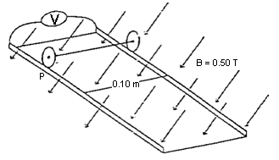

a) The axle is allowed to roll down the track. At the instant when its speed is
0.400 m s⁻¹ what Emf should be indicated by the voltmeter?
(3 marks)

b) The axle is released from the point P. Which of the diagrams (A-D) below, bests represents the Emf as a function of distance (d), from point P? (circle the letter)
(1 mark)

A | B | C | D
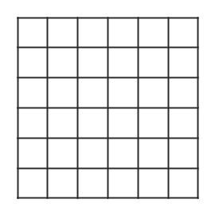
d (m)
E
m
f

(V)
d (m)
E
m
f

(V)
d (m)
E
m
f

(V)
d (m)
E
m
f

(V)

This page has been left intentionally blank

SECTION B : Problem Solving - 100 Marks (50%)

Attempt ALL 8 questions.
(15 marks)
1. A projectile P of mass 2.0 kg is launched from the top of the cliff 10 m high, with an initial speed of 3.50 m s⁻¹ at an angle of 45.0° from the horizontal.

a) Calculate the horizontal velocity of the projectile.
(2 marks)

b) Determine the final vertical velocity of the projectile.
(3 marks)

c) Calculate the projectile’s ‘time of flight’.
(3 marks)

d) Calculate the maximum height of the projectile.
(3 marks)

e) If the projectile was launched at 40° to the horizontal, would you expect it to have a greater or shorter range? Explain with the support of calculations.
(4 marks)

(12 marks)

*2. A uniform 10.0 m long ladder of mass 12.0 kg is resting against a smooth wall making an angle of 28.0° to the wall. A painter of mass 68.0 kg is standing
8.0 m along the ladder.
28.0 ⁰

a) Draw and label the above diagram with all relevant forces.
(2 marks)

a) Calculate the reacting force of the wall on the ladder.
(2 marks)

b) Calculate the vertical reaction force of the ground on the base of the ladder.
(2 marks)

c) Calculate the horizontal reaction force of the ground on the base of the ladder.
(2 marks)

d) Calculate the resultant force of the ground on the ladder.
(2 marks)

e) As the painter climbs down the ladder, what happens to the value of the reaction force of the wall? Explain why.
(2 marks)

(12 marks)
3. Leanne and Adele connect two similar speakers (A and B) to a sound frequency generator so that each speaker will emit sounds that are in phase and of equal frequency and intensity. They investigate the loudness of the sound produced at points along a line parallel to the speakers. They use a frequency of 685 Hz. Dimensions of the layout of the experiment are shown on the diagram.
1.60 m
2.30 m
R
S
T
Y
Z
B
A

Leanne walks along the line Y-Z and notices that maximum sound intensities occur at R and T (directly in front of the speakers) and at S (a point equidistant from each speaker). Quiet spots are noticed in between.

a) What is the cause of this effect? Explain clearly.
(2 marks)

b) From the diagram determine the difference in the distance between AT and BT.
(3 marks)

c) Use your result in b) to determine the velocity of sound during this experiment.
(3 marks)

d) Adele and Leanne decided to vary the sounds from each of the speakers to see what difference this would make. Describe and explain the difference that Leanne will notice as she walks from R to T if …

(i) The sound intensity from speaker A is doubled while B remains the same.
(2 marks)

(ii) The frequency of the sound from both speakers is doubled (1370 Hz) and the intensities kept equal.
(2 marks)

(12 marks)
4. A megaphone is a cone shaped tube. The user speaks into the narrow end and the sound comes out the wide end.

The intensity of a sound source is measured at various distances in front of a megaphone producing a constant 1 kHz sound on a still day. The following results were obtained.

Result Nº | Units | 1 | 2 | 3 | 4 | 5 | 6 | 7
Distance  (r) | m | 0.45 | 0.65 | 0.85 | 1.05 | 1.25 | 1.45 | 1.65
Intensity (I)  (x 10⁻⁸) | Wm⁻² | 39.51 | 18.93 | 11.07 | 7.26 | 9.12 | 3.80 | 2.94

It is hypothesized that the relationship between intensity and distance for the megaphone is…
I = ___P ____
0.125 π r²

a) What is the independent variable? ___________________
(1 mark)

b) What is the dependent variable? ___________________
(1 mark)

c) What type of mathematical relationship exists between distance and intensity?
(1 mark)
_____________________________________________________

d) The student wishes to plot the above data as a straight line. In the data table above manipulate the independent or dependant variable so that this can be achieved.
(2 marks)

e) Manually graph the appropriate data from the data table to produce a straight line.
(3 marks)


f) Calculate the slope of the line. Show all working on the graph paper itself.
(1 mark)

h) Calculate value of P in the formula.
(1 mark)

i) Explain why the data is or is not reliable.
(1 mark)

j) Explain why the hypothesis is or is not valid.
(1 mark)
(12 marks)
5. A local-area transformer is connected to a SECWA substation through wires with a total resistance of 4.00 ohm. The transformer, which can be assumed to be 100% efficient, has an input voltage of 8.00 x 10³ V. This transformer supplies a group of local houses with electricity at 240 V, at a rate of 400 kW. (4.00 x 10⁵ W). All numbers quoted are root mean square (RMS) values.

TRANSFORMER
2.0 Ω
2.0 Ω
to local area
240 V
8000 V

SUBSTATION

a) If the secondary winding of the transformer has 120 turns, how many turns are there on the primary winding?
(2 marks)

b) What is the current flowing in the wires from the substation to the local-area transformer?
(2 marks)

c) What is the power loss in the wires between the substation and the local area transformer?
(2 marks)

d) At what voltage is the substation supplying the electricity?
(2 marks)

e) Although it is assumed that this transformer is 100% efficient, in reality they are not. Explain two ways in which a transformer may lose some of its power.
(2 marks)

f) Explain how high voltage overhead power lines could cause problems with communications (e.g. telecom) or other environmental concerns.
(2 marks)

(11 marks)
6. A student who is working in a computer shop over the school holidays takes the cooling fan from inside a computer and plugs it into a cathode ray oscilloscope (CRO). The student sets the fan spinning by pointing a cool hair dryer at it. The turning blades of the fan contain a motor. When the fan blades are forced to turn the motor acts as a generator. This is called a wind turbine.

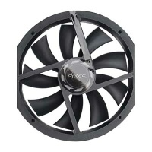

a) The wind blowing the turbine causes the blades to turn at 600 RPM (revolutions per minute). What is the frequency of the turbine?
(1 mark)

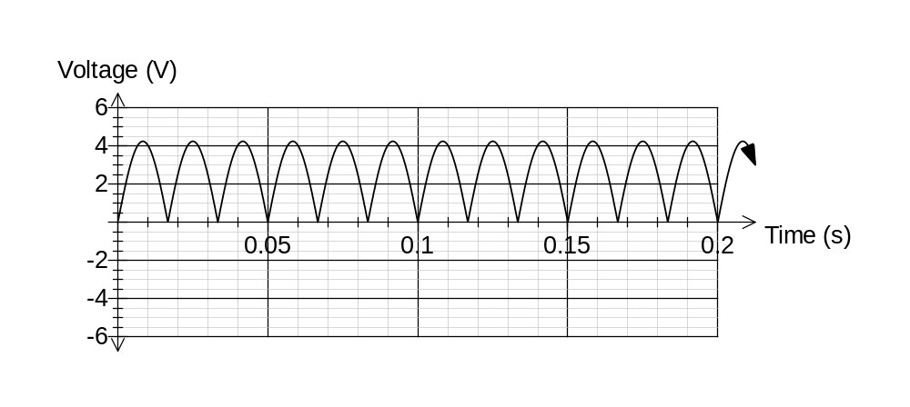The CRO produces a graph shown below.

b) Is the turbine an AC or DC appliance? ___________________
(1 mark)

c) How many armatures exist inside the turbine? ___________________
(1 mark)

d) What is the peak voltage produced by the turbine? ___________________
(1 mark)

e) What is the RMS (root mean squared) voltage produced by the generator?
(1 mark)
f) If each armature contain 100 turns and has a cross sectional area of
3.142 x 10⁻⁴ m², what is the magnetic flux density created by the permanent magnets inside the turbine?
(3 marks)

g) The student now connects a light bulb with a resistance of 2.4 Ω. What is the energy converted to light in 1 minute assuming that the bulb is 100% efficient?
(2 marks)

h) If the turbine turns twice as fast, the power output will …(please circle 1 only)
(1 mark)

a) Halve b) Remain constant c) Double d) Quadruple

(14 marks)
*7. The graph shows the relation between force applied and compression for a steel spring.

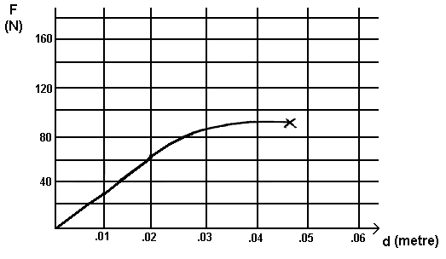

a) Label the elastic and plastic regions of compression on the graph.
(1 mark)

b) Determine the spring constant “ k ” using numbers estimated from the graph.
(2 marks)

c) Calculate the energy stored in the spring when it is compressed 4.00cm.
(You may have to approximate – use the graph)
(2 marks)

d) If the force on the spring is released after being compressed 4.00cm, by how much will it be deformed?
(1 mark)
e) The spring has an original length of 20 cm. The wire from which the spring is made has a cross sectional area of 3 mm². What is the Young’s modulus for the spring?
(4 marks)

f) Is the spring brittle or plastic in nature? Explain.
(2 marks)

g) What is the ultimate stress the spring can withstand according to the graph?
(1 mark)

h) An engineer recommends a “safety factor of 5” when using this spring. What is the greatest force to which the spring should be exposed while just adhering to this safety factor?
(1 mark)

(12 marks)
8. In the mass spectrometer below, singly charged oxygen ions enter a 0.47 T magnetic field with a kinetic energy of 3.2 x 10⁻¹⁵ J. The oxygen ions have a mass of 2.6569 x 10⁻²⁶ kg.

Ion Gun
Target
Uniform B Field

a) If the ions are deflected to the target along the path shown, determine if they carry a positive or negative charge.
(1 mark)
Positive Negative (Please circle one only)

b) What is the potential difference used to accelerate the ion in the ion gun?
(2 marks)

c) Where should the centre of the target be placed relative to the ion gun?
(5 marks)

d) The modifications below are made to the particle fired from the ion gun. You wish the modified particle to follow the identical pathway shown in the previous diagram. What will you do to the direction and magnitude of the magnetic field to achieve this if …
(4 marks)

Modification to original situation | State direction of B field required | State magnitude of B field required
Original charge on particle is reversed and doubled. Original kinetic energy is the same.

Original charge is unchanged but original kinetic energy of ion is reduced to 1/9 ^{th} its original value.

SECTION C : Comprehension and Interpretation - 40 Marks (20%)
Read the passages below carefully and answer all of the questions at the end of the passages. Candidates are reminded of the need for correct English and clear and precise presentation of answers. Diagrams (sketches), equations and/or numerical results should be included as appropriate.

Show all working out for questions requiring numerical answers.
_____________________________________________________________________

1.
America cuts its launchers down to size
(20 marks)
(Paragraph 1)
Pegasus, the first new rocket to be developed in the US since the shuttle, is due to be launched into orbit from Edwards Air Force base in California next week. Designed and built by a private company, Pegasus aims to break into the emerging market for small, lightweight satellites that can be launched quickly and cheaply. It is attracting attention from the US government and military as well as the aerospace industry.

(Paragraph 2)
Pegasus takes off from the wing of a B52 aircraft rather than the ground. The B52 carries the rocket to an altitude of about 13 000 metres, clear of most of the atmosphere. When the aircraft has reached a speed of about Mach 0.84 hooks are unclasped to release the Pegasus. Five seconds later, as the B52 veers away, the first-stage rocket fires. By launching from the air, Pegasus can place in orbit a cargo about twice as heavy as a ground-based launcher of its size.

(Paragraph 3)
Three rocket motors fire in sequence to lift the cargo into orbit. The first rocket stage is unusual because it has wings, providing lift when the launcher is released from the B52. During the 78 seconds that the first stage fires, accelerating Pegasus from Mach 0.84 to Mach 8, engineers control the rocket’s trajectory by adjusting control surfaces on the wings. The rocket’s nozzles are fixed. The second and third stages are traditional rocket motors, and the exhaust nozzles swivel to direct the launcher’s course.

(Paragraph 4)
Compared with other launchers such as Ariane, the shuttle, and Titan, Pegasus is a midget. The rocket will launch small satellites, weighing between about 130 and 410 kilograms, into orbit close to Earth. By comparison, the largest Ariane rocket can launch 4.2 tonnes. Peter Glaser, a space consultant for the firm Arthur D Little, says: “Governments prefer big spectacular space ventures, but a lot of science could be done more cheaply with small satellites.”

(Paragraph 5)
By planning to launch small satellites, OSC will be competing for what is still a tiny market. The only company with a proven history of launches for small satellites is LTV Aerospace, with its Scout launcher. However, several companies are trying to break into the market. Small satellites can also hitch a ride into orbit with larger spacecraft launched by big rockets – with the obvious drawback that the small satellite has to go where the main cargo is going.

(Paragraph 6)
Meanwhile, OSC has come up with another idea that would give it some work. Last month, the company formed a subsidiary called Orbital Communications and filed a request with the Federal Communications Commission for permission to launch 20 small satellites in low-Earth orbit to provide a cheap communications service. OSC plans to have this service in place by 1993.

(Paragraph 7)
At the moment, communications satellites are large and expensive. Their orbits are 36 000 kilometres above the equator. In this type of orbit, a satellite remains stationary with respect to one spot on the ground, and can relay telephone conversations and television programs continuously. For some communications, though, it does not matter if the relay does not work all of the time. OSC believes that there is a market for services that relay short messages – perhaps, for instance, repeatedly broadcasting the position of someone who had an accident to medical services.

(Paragraph 8)
OSC’s idea is to place 20 small satellites into orbits 270 kilometres above the Earth. These satellites would between them provide cover for about 95 per cent of the time. As one disappeared from view, another would appear over the horizon, and contact would not be lost for more than a minute. Each satellite would weigh 150 kilograms, including fuel, and would last for seven years. Two would be in polar orbit, and six would be in each of three different circular orbits inclined to the equator.

(Paragraph 9)
With satellites so close to Earth, OSC says that only about 2 to 5 watts of power would be needed to transmit short messages from small hand-held transmitters on the ground. Pike, from the Federation of American Scientists, says of the plan: “It’s the only scheme I’ve heard of for a small launcher that makes sense.”

a) What acceleration does Pegasus have during the first stage of rocket firing?
(Note :- Mach 1.00 = Speed of sound in air = 3.30 x 10² m s⁻¹)
(3 marks)

b) Explain why launching from the air can allow for larger cargoes to be carried by Pegasus than similar sized ground based launchers.
(2 marks)

c) When rockets are launched into space from the surface of the earth two of the factors considered are given below. For each factor explain why it is desirable or advantageous.

(i) They are launched in an easterly direction.
(1 mark)

(ii) The launching sites are as close to the equator as possible.
(1 mark)

d) What velocity must Pegasus give a small satellite to put it in a circular Earth orbit at the height recommended by the OSC (Orbital Sciences Corporation)?
(Paragraph 8)
(3 marks)

e) Explain what would happen to the orbit of the satellites after they ran out of fuel in seven years time? Why?
(2 marks)

f) (i) What is meant by a geostationary orbit?
(1 mark)

(ii) Why do these satellites need to be placed in orbits above the equator?
(1 mark)

g) Why can’t satellites be launched into orbits at distances of less than 150km above the Earth?
(1 mark)

h) The article states that communication satellites are in orbit 36 000 km above the equator. Verify this figure by using appropriate formulas.
(2 marks)

i) If a 5.00 W transmitter sends a signal to the satellite positioned 270 km above, what is the intensity of the signal from the transmitter at the location of the satellite? Assume that the ground below the transmitter is a perfect reflector.
(3 marks)

2.
Oceanographers make a noise to test the water
(20 marks)
(Paragraph 1)
An elaborate experiment to use sound waves to measure the temperature of all of the world’s oceans simultaneously is being planned by scientists from the US and Australia. They aim to determine whether the greenhouse effect has caused the temperatures of the oceans to rise as climate modelers predict.

(Paragraph 2)
The plan involves mounting a permanent sound source in the waters off Heard Island in the southern Indian Ocean. The scientists want to use the time it takes for sound to travel a known distance to determine the water’s average temperature. The time it takes to arrive – as much as three hours over thousands of kilometres – depends on the temperature and density of the water. If the oceans are warming, the density of the water will decrease and the sound will travel faster. “In effect, we will set up a global ocean thermometer,” says Walter Munk from the Scripps Institute of Oceanography, in La Jolla, California, where the technique is being pioneered.

(Paragraph 3)
A survey to determine exactly where off Heard Island the sound source should be located will begin next month as part of the maiden voyage of the Australian research vessel, Aurora Australis. In January next year, the researchers will hold a week-long feasibility study, involving acoustic receivers at 13 research stations on all of the continents (see Map).

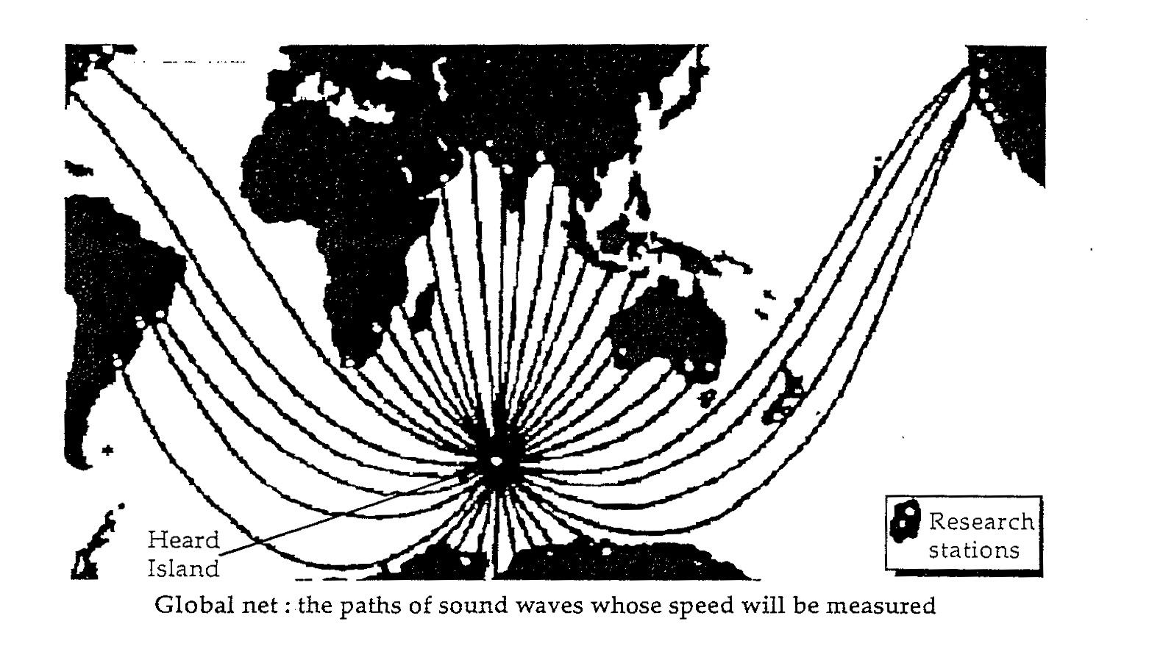
(Paragraph 4)
If the study is successful, the team hopes to begin the full experiment, which will take 10 years to complete. Details of the experiment will be announced next week in Hobart by Andrew Frobe from the Australian research organization CSIRO’s Division of Oceanography. He will make the announcement at a meeting of the Australian and New Zealand Association for the Advancement of Science (ANZAAS).

(Paragraph 5)
According to some climate models, the world will become warmer within the next 30 years than at any other time over the past 200 000 years. Mean global temperatures could rise by almost 4°C. The models predict that the oceans will act as a “sink” for any increase in atmospheric heat. If this is correct, then the oceans should provide an accurate picture of global warming. The temperature of the sea may rise by as much as one-tenth of a degree every year, according to some models.

(Paragraph 6)
But oceanographers such as Munk, say that climate modelers do not yet have sufficient data to model the oceans accurately. The ocean acoustic experiment should yield more accurate information about the temperature of deep waters than other methods, such as remote sensing by satellite or readings from ships.

(Paragraph 7)
Sound in water is affected almost entirely by temperature and pressure; it is this phenomenon that the scientists are exploiting. A ‘sound channel’, where the speed of sound is at its minimum, exists at about one kilometre below the surface. This path is sandwiched between the warmer water above and the water below where the pressure is higher. These two channels allow sound to propagate at faster speeds. The depth of the channel depends on the temperature of the water – it is lower in warmer water near the equator and higher near the poles. The ‘axial depth’, or centre of the channel, occurs where the change in temperature becomes progressively smaller as the pressure continues to increase. The sound is refracted as it bounces between the water above and below the channel.

(Paragraph 8)
Munk became convinced that the experiment was possible after reworking data from an experiment carried out in 1960 off the west coast of Australia. Hydrophones about 16 000 kilometres away in Bermuda picked up a detonation of 130 kilograms of TNT at a depth of 1 kilometre. The researchers concluded that the sound followed a path called the Great Circle Route which is the shortest path between any two points on the globe.

(Paragraph 9)
Munk thought that the propagation of the sound would have been affected by the fact that the Earth is not a perfect sphere. Instead, the sound followed a geodesic path that was influenced by the colder water at higher latitudes. His calculations were an exact fit with the time the sound took to reach Bermuda.

(Paragraph 10)
By using this ‘refracted geodesic’ path, Munk and the others believe that it will be possible to transmit sound from Heard Island to numerous parts of the world’s five ocean basins – the North and South Atlantic, the North and South Pacific and the Indian Ocean.

(Paragraph 11)
The acoustic source to be used off Heard Island will transmit at a lower frequency – about 50 to 60 hertz – where there will be less interferences from ships and other sources of noise.

a) What is the principle behind setting up a global ocean thermometer?
(2 marks)

b) On what two factors does the travel time of the sound depend?
(2 marks)

c) In the next thirty years it is feared that the mean global temperature could rise by almost 4°C. If this is correct why will the oceans provide an accurate picture of global warming?
(2 marks)

d) What are the authors referring to when talking about sound channels?
(2 marks)

e) What property of sound keeps the wave in the sound channel? A diagram may be useful in your explanation.
(2 marks)

f) The acoustic source used off Heard Island is 57 Hz. For what reasons has this low frequency been selected?
(2 marks)

g) If the average velocity of the sound wave in the sound channel is 1450 m s⁻¹, what is the wavelength of the wave?
(3 marks)

h) How long will it take for a pulse to travel from Heard Island to a receiver off Ascension Island some 9200 km away?
(3 marks)

i) It was found that the measured time was slightly greater than you calculated in h). Suggest a reason for the increase.
(2 marks)

End Of Exam

References / Acknowledgements

www.antec.com – cooling fans (14/7/2009)

Semester II Exam
2009 Question/Answer Booklet

PHYSICS 12

TIME ALLOWED FOR THIS PAPER

Reading time before commencing work: Ten minutes
Working time for paper: Three hours

MATERIALS REQUIRED/RECOMMENDED FOR THIS PAPER

TO BE PROVIDED BY THE CANDIDATE

Affix Sticker Here

ANSWER KEY
Standard Items
- Pens.
- Pencils.
- Eraser or correction fluid.
- Ruler.

Special Items
- Physical formulae and constants sheet.
- Drawing implements.
- Templates.
- Calculators satisfying the conditions set by the Curriculum Council.

TO BE PROVIDED BY THE SUPERVISOR
This Question/Answer Booklet.
Physical Formulae and Constants sheet.

IMPORTANT NOTE TO CANDIDATES

No other items may be taken into the examination room.

It is your responsibility to ensure that you do not have any unauthorised notes or other items of a non-personal nature in the examination room. Please check carefully and if you have any unauthorised material with you hand it in to the supervisor BEFORE reading any further.

 | Short Answer | Problem Solving | Comprehension | Total
Marks | /60 | /100 | /40 | /200
% | /30 | /50 | /20 | /100
STRUCTURE OF THE PAPER

Section | No of  questions | No of marks  out of 200 | Proportion of  exam total
A: Short Answers | 15 | 60 | 30%
B: Problem Solving | 8 | 100 | 50%
C: Comprehension & Interpretation | 2 | 40 | 20%

INSTRUCTIONS TO CANDIDATES

Write your answers in the spaces provided beneath each question in sections A and B
The value of each question in section A is four marks.

Note that (where appropriate) answers should be given numerically and they should be evaluated and not left in fractional or radical form. Give all numerical answers to three significant figures except in the cases for which estimates are required.

Questions containing specific instructions to show working should be answered with a complete, logical, clear sequence of reasoning showing how the final answer was arrived at; correct answers which do not show working out will not be awarded full marks.

Questions containing the instruction estimate may give insufficient numerical data for their solution. Candidates should provide appropriate figures to enable an approximate solution to be obtained.

Candidates should remember that when descriptive answers are required, they should be used to display understanding of the aims and objectives of the Physics 12 course. A descriptive answer, which addresses the context of a question without displaying an understanding of physics principles, will not attract marks.

Despite an incorrect final result, credit may be obtained for method and working, provided these are clearly and legibly set out.
SECTION A : Short Answers - 60 Marks (30%)

Attempt ALL 15 questions in this section.
Show all working out. (4 marks each)

1. A stunt driver takes his motorcycle around a vertical loop-the-loop of diameter 9.80 m. What minimum speed must the cycle have at the top point of the loop in order to stay on the track?
(4 marks)

-N + - mg = -mv² / r

at minimum speed the normal force becomes zero.

-mg =
g =
= v
v = 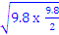
v = 6.93 m/s

Common mistakes
Used the diameter as the radius
Forgot the law that was being applied and so did not know how to proceed.

2. Explain with aid of force diagrams, why an athlete leans into a curve when running round a bend in a track.
(4 marks)
- All forces pass through centre of mass
- This eliminates torque effects
- This stops runner tipping over
- Friction supplies the centripetal force only.

Free Body Diagram
mg
Reaction
Free Body Diagram
Friciton
mg
N
Free Body Diagram

or

Common mistakes
Putting the Fc on the free body diagram
Attaching forces at the wrong location on the runner
Deciding that the ground was banked when it was actually flat.
No mention of torque

3. A body mass of mass “m” rests on a plane surface inclined at an angle X° to the horizontal. Find an expression for the friction force parallel to the plane in terms of weight.
(4 marks)
N
Ff
F_{f}
m

mg
mg
N
X
X

ΣF = 0
Sin X = F_{f} / mg
F_{f} = mg Sin X

4. The diagram shows a person using a walking frame. Very old people, or people weakened by illness, often use these frames as aids. Imagine you are the physiotherapist who first designed the walking frame. Give an account of its purpose and use from a physics perspective.
(4 marks)

The purpose of the frame is to increase the size of the base which increases stability
The frame does lower the COM of the system slightly which increases stability.
The person with the frame will be harder to topple because they have to be tipped through a larger angle before the weight vector from the enter of mass acts outside the base

mg
mg

Common mistakes
Did not mention torque. The idea that toppling occurs when the weight vector from the centre of mass acts outside the base creating a toppling torque

5. A gymnast hangs from two rings fixed to a wall as shown in the diagram below. He is stationary. His arms make an angle of 20.0 ⁰ with the horizontal. The weight of his body is 800 N. Estimate the effective tension in one of his arms.
(4 marks)
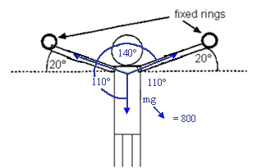

= =

=

=

= 1170 N by symmetry = 1170 N also

Common Mistakes
Some people got the correct answer and divided by two for some reason?
You could have solved by components but would have taken longer.
Some people are getting confused between sin and cos relationships in triangles

6. A uniform bridge has a mass of 450 tonnes and is supported by two concrete piers (A & B) 80.0 m apart. A truck of mass 40.0 tonnes is parked 15.0 m from pier A.
A
B
Bridge
Piers

a) Which pier exerts the greatest force?

A (some people said A but calculated b by accident
(1 mark)

b) Calculate the force exerted by this pier.
= ABOUT B
A x 80 = (40 000 x 9.8 x 65) + (450 000 x 9.8 x 40)
A = =

A = 2.52 x 10⁶ N up
Comments
Draw all distances and pivots on the diagram. You cannot calculate the torque at the pivot.

(3 marks)
7. Samples of hardwood and cast iron have the following approximate tensile and compressive strengths.

Material | Approximate compressive strength (MN m⁻²) | Approximate tensile strength (MN m⁻²)
Hardwood | 50 | 100
Cast Iron | 500 | 150

Beams in bridges and buildings are often subjected to forces like those shown by the arrows in the diagram below. When cast iron beams are used like this, they are often designed with a cross-section similar to that shown below. The lower part of the beam is much thicker than the upper part. Explain why it is better for the lower part of the beam to be made thicker than the top part. Your answer should include reference to the table above.
Cross section of beam
Side View

(4 marks)
- The lower part of the beam is under tension and the top is under compression
- Cast Iron is weaker under tension than compression (see data table)
- To compensate for this the I beam is made thicker and wider in the lower part.
- By increasing area you decrease stress for the same sized force.

8. Below is a cross section through the earth showing the paths followed by seismic waves generated by an earthquake at the focus.
Focus
A
B
C
a) What type of wave is an earthquake?
mechanical

b) Name the wave process happening at A.
refraction (not diffraction)

c) Name the wave process happening at B.
reflection

d) Name the wave process happening at C.
refraction

(4 marks)
9. The thickest string of a guitar is tuned to the musical note E which is 82.5Hz.
The string next to it is tuned to the note A at 110 Hz.

a) Draw the standing (stationary) wave of the E string vibrating at its fourth harmonic.
(1 mark)

b) Draw the standing (stationary) wave of the A string vibrating at its third harmonic.
(1 mark)
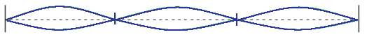

c) What frequencies would you hear if both of these harmonics were played together?
(2 marks)
f_{n} = f₁ x n f_{n} = f₁ x n

f₄ = 82.5 x 4 f₃ = 110 x 3

f₄ = 330 H₂ f₃ = 330 H₂

Same frequency
Comments
Many misread the question and compared the fundamental frequencies. The question asks for a comparison of the harmonic frequencies

10. Match each of the following situations with a type of spectra by completing the table below.
(4 marks)
Situation | Absorption  Or  Emission | Line, Band or Continuous
An ionic salt dissolved in water is sprayed as a solution into a Bunsen burner flame. | Emission | Line
Carbon dioxide at low pressure in a discharge tube collides with high speed electrons. | Emission | Band
A Tungsten filament in a light globe glows when electricity is passed through it. | Emission | Continuous
Fraunhoffer lines are observed when light from the sun which has passed through the earth’s atmosphere is examined. | Absorption | Line & band

Comment
Both answers must be correct to get the mark.

11. When violet light of wavelength 4286 Ǻ is shone onto the surface of a solar cell, electrons leave the surface of the cell with a velocity of 4.67 x 10⁵ m s⁻¹. These electrons are collected (and accumulate on) a metal fly wire mesh positioned 1.00 cm above the surface of the solar cell. The surface of the cell and the fly wire are in a vacuum.
UV
electron
Metal (Positive)
Mesh (Negative)
Vacuum

What is the ionization energy of the solar cell surface in electron volts?
(4 marks)
hf = work function + ½mv² (1)

= + ½ x 9.11 x 10⁻³¹ x (4.67 x 10⁵)²

4.6406 x 10⁻¹⁹ = + 9.934 x 10⁻²⁰ (2)

= 3.65 x 10⁻¹⁹ J

E (eV) = 3.65 x 10⁻¹⁹ = 1.6 x 10⁻¹⁹ = 2.28 eV (1)

12 . Two identical bar magnets A and B are each dropped down a tube. A is dropped down a copper tube and B is dropped down a plastic tube. If the time it takes for the bar magnets to fall is accurately timed, which magnet A or B will take longer to reach the ground? Explain why.
(4 marks)

- “A” takes longer (1)
- Lenz’s law (1)
- As magnet passes down the metal tube a current is induced in the pipe The induced current creates its own magnetic field which opposes the original and so slows the magnets decent. (1)
- Does not work in plastic because plastic pipe (insulator) will not allow a current to flow. (1)

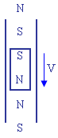
13. In a Milliken type experiment an oil drop of mass 5.00 x 10⁻¹² kg is placed between two parallel plates charged with a potential difference of 7.66 x 10⁵ V. The oil drop hovers in the field half way between the plates. The plates are
1.00 m apart in a vacuum and the oil drop is stationary. What is the magnitude of the negative charge on the oil drop?
(4 marks)
7.66 x 10⁵ V
Plates
Oil Drop
Side View

mg = qE

E = = = 7.66 x 10⁵ V/m

5 x 10⁻¹² x 9.8 = q x 7.66 x 10⁵

q = -6.40 x 10⁻¹⁷ C

14. A metal fan has its blades spinning with the south end of a bar magnet positioned behind the blades. A wire is joined at one end to a conducting brush which touches the edge of each blade as it passes over the bar magnet. The other end of the wire is joined to the metal body of the fan to complete the circuit.
Front view Top view
N

S
X Y
Fan blades
External Circuit
(wires)

a) In what direction does the current flow in the external circuit (wires)?
(please circle one answer only.)
(1 mark)
A | X →Y
B | Y → X
C | Alternating current
D | No current flows

b) If the fan turns 200 times in one minute, how many pulses of current will the fan produce each second on average?
(3 marks)
f = (1)
f = 3.3 H₂
pulse =8 x 3.3 Hz (1)
pulses = 26.6 pulses (1)
15. The light metal wheels and axle from a toy train wagon can roll down a sloping section of track as shown in the figure below.

The axle is 0.100 m long. The rails of the track are insulated from each other and have negligible resistance. The rails are connected to a voltmeter that draws no current, marked V in the diagram. A uniform magnetic field of strength 0.500 T has its direction perpendicular to the plane of the track.

a) The axle is allowed to roll down the track. At the instant when its speed is
0.400 m s⁻¹ what Emf should be indicated by the voltmeter?
(3 marks)
EMF = l v B (1)
EMF = 0.1 x 0.4 x 0.50 (1)
EMF = 2.00 x 10⁻² V (1)

b) The axle is released from the point P. Which of the diagrams (A-D) below, bests represents the Emf as a function of distance (d), from point P? (circle the letter)
(1 mark)

A | B | C | D
d (m)
E
m
f

(V)
d (m)
E
m
f

(V)
d (m)
E
m
f

(V)
d (m)
E
m
f

(V)

Comments

The acceleration of the axle down the slope is not constant because of lens’s law. The faster the axle rolls, the more current, the more force opposing the cause of the change (gravitational acceleration).
This page has been left intentionally blank

SECTION B : Problem Solving - 100 Marks (50%)

Attempt ALL 8 questions.
(15 marks)
1. A projectile P of mass 2.0 kg is launched from the top of the cliff 10 m high, with an initial speed of 3.50 m s⁻¹ at an angle of 45.0° from the horizontal.

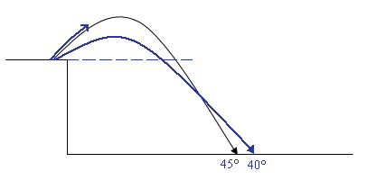

a) Calculate the horizontal velocity of the projectile.
(2 marks)

U_{H} = 3.5 Cos 45° (1)
U_{H}= 2.47 m/s horizontal (1)

Comments
Careful of sin and cos
Use the diagram or draw a separate one.

b) Determine the final vertical velocity of the projectile.
(3 marks)

u_{v} = 3.5 Sin 45° = 2.47 m/s vertical

v = u + at

v² = u² + 2as (1)

s = ut + ½at²

v² = (2.47)² + 2 x (-9.8) x -10 (1)

v² = 6.1009 + 196

v = 14.2 m/s down (1)

c) Calculate the projectile’s ‘time of flight’.
(3 marks)

v = u + at (1)

-14.216 = 2.47 + (-9.8) x t (1)

= t

t = 1.70 s (1)

d) Calculate the maximum height of the projectile.
(3 marks)
v² = u² + 2as (1)

0 = 2.47² + 2 x -9.8 x s (1)

= s

s = 0.311 m above the cliff (origin) (1)

Comment
If the question does not request the maximum height relative to the landing position then the maximum height is to always be assumed to be relative to the takeoff (origin) position. If in doubt state in your final answer where the height is relative to.

e) If the projectile was launched at 40° to the horizontal, would you expect it to have a greater or shorter range? Explain with the support of calculations.
(4 marks)

45°
u = s = u x t
s_{h} = 3.5 Cos 45° x 1.70
s_{h} = 4.21 m
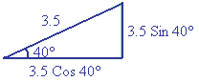

40°
u_{v} = 3.5 Sin 40° = 2.249 m/s up
u_{h} = 3.5 Cos 40° = 2.681 m/s right

V | H
s = ut + ½at²  - 10 = 2.249 t + ½ x -9.8 x t²  Solve mode  t = 1.676495 | u =  2.681 =  s = 4.49 m
The range for 40 degrees is longer.

(12 marks)
2. A uniform 10.0 m long ladder of mass 12.0 kg is resting against a smooth wall making an angle of 28.0° to the wall. A painter of mass 68.0 kg is standing
8.0 m along the ladder.
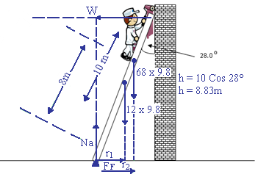
r₁ = 5 x Sin 28°  r₁ = 2.34m | r₂ = 8 Sin 28°  r₂ = 3.76m

Comments
Be careful with your labels
The wall is smooth!
The ground reaction force (Ff and Normal combined) is at a different angle to the ladder.

a) Draw and label the above diagram with all relevant forces.
(2 marks)
5 forces required, correctly drawn, with labels.
a) Calculate the reacting force of the wall on the ladder.
(2 marks)
Take moments about the base of the ladder.

=

(12 x 9.8 x 2.34) + (68 x 9.8 x 3.76) = W x 8.33

= W

W = 3.15 x 10² N

Comments
2 marks of if trig is bad on both sides of the equal sign. 1 mark of if trig is bad only on one side.

b) Calculate the vertical reaction force of the ground on the base of the ladder.
(2 marks)
=
N_{g} = (12 x 9.8) + (68 x 9.8) (1)
N_{g} = (117.6) + (666.4)
N_{g} = 784 N up (1)

c) Calculate the horizontal reaction force of the ground on the base of the ladder.
(2 marks)
=

F_{F} = W

F_{F} = 315 N

d) Calculate the resultant force of the ground on the ladder.
(2 marks)
Normal
Friction
Resultant
σ
R = 784² + 315²

R = 845 N

tan =

Answer = 845 N at 68.1° above horizontal

e) As the painter climbs down the ladder, what happens to the value of the reaction force of the wall? Explain why.
(2 marks)

Wall force reduces (1)

As painter descends, r₂ decrease, M of painters weight decreases, M of W also decreases but h doesn’t change so W must decrease. (1)

W↓ =
(12 marks)
3. Leanne and Adele connect two similar speakers (A and B) to a sound frequency generator so that each speaker will emit sounds that are in phase and of equal frequency and intensity. They investigate the loudness of the sound produced at points along a line parallel to the speakers. They use a frequency of 685 Hz. Dimensions of the layout of the experiment are shown on the diagram.
1.60 m
2.30 m
R
S
T
Y
Z
B
A

Leanne walks along the line Y-Z and notices that maximum sound intensities occur at R and T (directly in front of the speakers) and at S (a point equidistant from each speaker). Quiet spots are noticed in between.

a) What is the cause of this effect? Explain clearly.
(2 marks)
Superposition (1)

Constructive interference = (loud spots) = 2 crests coincide
Destructive interference = (quiet spots) = crest & trough coincide
(1)

b) From the diagram determine the difference in the distance between AT and BT.
(3 marks)

Path difference = - 2.3

= 2.8017851 – 2.3 (2)

P.D. = 0.502 m (1)

c) Use your result in b) to determine the velocity of sound during this experiment.
(3 marks)

n = 1 n = = (1)

=

= 0.502 (1)

v = x f

v = 0.502 x 685

v = 344 m/s (1)

d) Adele and Leanne decided to vary the sounds from each of the speakers to see what difference this would make. Describe and explain the difference that Leanne will notice as she walks from R to T if …

(i) The sound intensity from speaker A is doubled while B remains the same.
(2 marks)

Loud spots are louder and quiet sports are louder. (1)

Because the amplitude of one of the waves is bigger. (1)

(ii) The frequency of the sound from both speakers is doubled (1370 Hz) and the intensities kept equal.
(2 marks)

Position of loud and quiet spots alters to be closer. (1)

Spacing between loud and quiet spots halves because has halved. (1)

Comments

Must have a statement about the observed change and a physics explanation as to how that change has occurred to get both marks.
(12 marks)
4. A megaphone is a cone shaped tube. The user speaks into the narrow end and the sound comes out the wide end.

The intensity of a sound source is measured at various distances in front of a megaphone producing a constant 1 kHz sound on a still day. The following results were obtained.

Result Nº | Units | 1 | 2 | 3 | 4 | 5 | 6 | 7
Distance  (r) | m | 0.45 | 0.65 | 0.85 | 1.05 | 1.25 | 1.45 | 1.65
 |  | 4.94 | 2.37 | 1.38 | 0.91 | 0.64 | 0.46 | 0.37
Intensity (I)  (x 10⁻⁸) | Wm⁻² | 39.51 | 18.93 | 11.07 | 7.26 | 9.12 | 3.80 | 2.94

It is hypothesized that the relationship between intensity and distance for the megaphone is…
I = ___P ____
0.125 π r²

a) What is the independent variable? r (distance)
(1 mark)

b) What is the dependent variable? I
(1 mark)

c) What type of mathematical relationship exists between distance and intensity?
(1 mark)
Power or reciprocate or hyperbola (name of shape when I plots against r).

d) The student wishes to plot the above data as a straight line. In the data table above manipulate the independent or dependant variable so that this can be achieved.
(2 marks)

- 1 mark per blank box
- must complete all of one row

e) Manually graph the appropriate data from the data table to produce a straight line.
(3 marks)
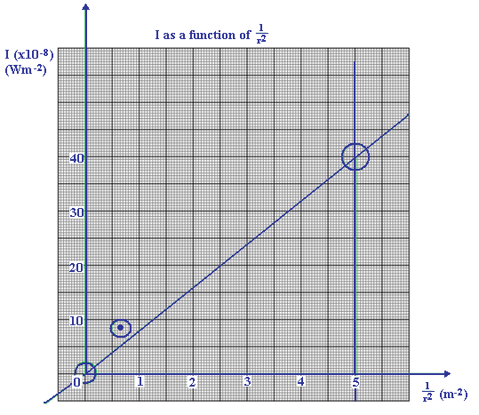
Comments
- Title
- Units
- Power of ten
- Draw rise over run triangle on graph.
- Ignore outliers
f) Calculate the slope of the line. Show all working on the graph paper itself.
(1 mark)
Slope = = = 8 x 10⁻⁸

h) Calculate value of P in the formula.
(1 mark)
Slope = → 8 x 10⁻⁸ =

P = 8 x 10⁻⁸ x 0.125 x = 3.142 x 10⁻⁸

i) Explain why the data is or is not reliable.
(1 mark)
Is reliable – clear pattern
One outlier does not make data unreliable.

j) Explain why the hypothesis is or is not valid.
(1 mark)
Hypothesis predicts straight line for
I x

Data supports hypothesis ∴ hypothesis is valid.
E.g. pattern created by data matches pattern predicted by hypothesis so hypothesis is valid.
(12 marks)
5. A local-area transformer is connected to a SECWA substation through wires with a total resistance of 4.00 ohm. The transformer, which can be assumed to be 100% efficient, has an input voltage of 8.00 x 10³ V. This transformer supplies a group of local houses with electricity at 240 V, at a rate of 400 kW. (4.00 x 10⁵ W). All numbers quoted are root mean square (RMS) values.

TRANSFORMER
2.0 Ω
2.0 Ω
to local area
240 V
8000 V

SUBSTATION

a) If the secondary winding of the transformer has 120 turns, how many turns are there on the primary winding?
(2 marks)
=

= (1)

Np = 4.00 X 10³ windings (1)

b) What is the current flowing in the wires from the substation to the local-area transformer?
(2 marks)
P = VI

400 000 = 8000 x I (1)

I = 50.0 A (1)

c) What is the power loss in the wires between the substation and the local area transformer?
(2 marks)
P_{LOSS} = I²R

P_{LOSS} = 50² X 4 (1)

P_{LOSS} = 2500 X 4

P_{LOSS} = 1.00 X 10⁴ W (1)

d) At what voltage is the substation supplying the electricity?
(2 marks)
P_{TOTAL} = P_{LOSS} + P_{SUPPLIED}

P_{TOTAL} = 10 000 + 400 000

P_{TOTAL} = 410 000 W (1)

Current is conserved in a power line.

P = VI → 410 000 = V x 50 → V = 8.20 x 10³ V (1)

Comments
Alternative solution is to work out the voltage loss in wires to transformer (200 V) and add this voltage to the voltage actually delivered to the primary of the transformer (8000 V). Power method is more trustworthy.

V = IR
V = 50 x 4
V = 200 V (1)

V _{total} = 8000 + 200
V _{total} = 8.20 x 10³ V (1)

e) Although it is assumed that this transformer is 100% efficient, in reality they are not. Explain two ways in which a transformer may lose some of its power.
(2 marks)

Field loss due to field created by primary not passing through the secondary– use soft iron
Eddy current – laminate
Wire resistance – use copper (thick)
Temperature affects ↑ R – use heat sink/radiator to keep cool

Comments
Any two non - similar ideas.

f) Explain how high voltage overhead power lines could cause problems with communications (e.g. telecom) or other environmental concerns.
(2 marks)

Magnetic and electric fields connected by the power lines may interfere (constructive/destructive) with radio waves and other EM waves resulting in fluctuations in intensity.

EM waves from power lines alter the path of particular radiation possibly focusing radiation onto humans on the ground, causing cancer.

Comments
Must contain explanation of how the effect is created.

(11 marks)
6. A student who is working in a computer shop over the school holidays takes the cooling fan from inside a computer and plugs it into a cathode ray oscilloscope (CRO). The student sets the fan spinning by pointing a cool hair dryer at it. The turning blades of the fan contain a motor. When the fan blades are forced to turn the motor acts as a generator. This is called a wind turbine.

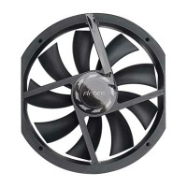
a) The wind blowing the turbine causes the blades to turn at 600 RPM (revolutions per minute). What is the frequency of the turbine?
(1 mark)
f = 10 Hz

The CRO produces a graph shown below.

b) Is the turbine an AC or DC appliance? DC
(1 mark)

c) How many armatures exist inside the turbine? 3
(1 mark)

d) What is the peak voltage produced by the turbine?
(1 mark)

e) What is the RMS (root mean squared) voltage produced by the generator?
(1 mark)
V_{RMS} = 3.00V
f) If each armature contain 100 turns and has a cross sectional area of
3.142 x 10⁻⁴ m², what is the magnetic flux density created by the permanent magnets inside the turbine?
(3 marks)
V = (1)

3 = (1)

B = 1.989 x 10⁻¹ T (1)
Comments
Subtract one mark for each mistake
Better way since the change in the area is not a constant change but a sinusoidal change.

Emf _{peak} = nBA2πf

4.25 / = 100 x B x 3.142 x 10⁻⁴ x 2 x π x 10

B = 2.38 T?

g) The student now connects a light bulb with a resistance of 2.4 Ω. What is the energy converted to light in 1 minute assuming that the bulb is 100% efficient?
(2 marks)

P =
P = (1)
P = 3.75 W (1)

h) If the turbine turns twice as fast, the power output will …(please circle 1 only)
(1 mark)

a) Halve b) Remain constant c) Double d) Quadruple

Voltage doubles
Resistance is constant
So current doubles
P = VI so power quadruples
(14 marks)
7. The graph shows the relation between force applied and compression for a steel spring.

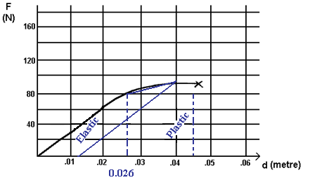

a) Label the elastic and plastic regions of compression on the graph.
(1 mark)

b) Determine the spring constant “ k ” using numbers estimated from the graph.
(2 marks)
F = kx

80 = k x 0.026 (1)

k = 3.07 x 10³ Nm⁻¹ (1)

c) Calculate the energy stored in the spring when it is compressed 4.00cm.
(You may have to approximate – use the graph)
(2 marks)
Area = Energy

1. ½ x 0.026 x 80 = 1.04 J

2. 0.014 x 80 = 1.12 J

3. ½ x 0.014 x (90 – 80) = 0.07 J

Total 2.23 J

d) If the force on the spring is released after being compressed 4.00cm, by how much will it be deformed?
(1 mark)
0.012 m + or – 0.003 cm
Or
nil depending on whether you believe it was in the plastic region or not.
e) The spring has an original length of 20 cm. The wire from which the spring is made has a cross sectional area of 3 mm². What is the Young’s modulus for the spring?
(4 marks)

3 mm² = 3 x 10⁻⁶ m²

Y =

Y = x bot F = kx = F = k

Y =

Y =

Y = 2.05 x 10⁵ Nm⁻²

f) Is the spring brittle or plastic in nature? Explain.
(2 marks)
Brittle. – Short plastic region if any. No dip. No flow.
Comment
Depends on explanation or the marks
g) What is the ultimate stress the spring can withstand according to the graph?
(1 mark)

= 3.00 x 10⁻⁷ N m⁻² (1 )

h) An engineer recommends a “safety factor of 5” when using this spring. What is the greatest force to which the spring should be exposed while just adhering to this safety factor?
(1 mark)
F = 90 x

F = 18.0 N (1)
(12 marks)
8. In the mass spectrometer below, singly charged oxygen ions enter a 0.47 T magnetic field with a kinetic energy of 3.2 x 10⁻¹⁵ J. The oxygen ions have a mass of 2.6569 x 10⁻²⁶ kg.

Ion Gun
Target
Uniform B Field

a) If the ions are deflected to the target along the path shown, determine if they carry a positive or negative charge.
(1 mark)
Positive Negative (Please circle one only)

b) What is the potential difference used to accelerate the ion in the ion gun?
(2 marks)
Ek = ½ mv² = qV

3.2 x 10⁻¹⁵ = 1.6 x 10⁻¹⁹ x V (1)

V = 20 000 V (1)

c) Where should the centre of the target be placed relative to the ion gun?
(5 marks)
d = ? qvB = (1)

r =
W = ½mv²

3.2 x 10⁻¹⁵ = 0.5 x 1.6569 x 10⁻²⁶ (1)

v = 4.91 x 10⁵ m/s (1)

r =

r = 1.73 x 10⁻¹

d = 3.46 x 10⁻² m

comments
some people are confused between voltage and velocity.

d) The modifications below are made to the particle fired from the ion gun. You wish the modified particle to follow the identical pathway shown in the previous diagram. What will you do to the direction and magnitude of the magnetic field to achieve this if …
(4 marks)

Modification to original situation | State direction of B field required | State magnitude of B field required
Original charge on particle is reversed and doubled. Original kinetic energy is the same. | Out of page | 0.47/2  0.235 T
Original charge is unchanged but original kinetic energy of ion is reduced to 1/9 ^{th} its original value. | Into page | 1/3 x 0.47  = 0.157 T

SECTION C : Comprehension and Interpretation - 40 Marks (20%)
Read the passages below carefully and answer all of the questions at the end of the passages. Candidates are reminded of the need for correct English and clear and precise presentation of answers. Diagrams (sketches), equations and/or numerical results should be included as appropriate.

Show all working out for questions requiring numerical answers.
_____________________________________________________________________

1.
America cuts its launchers down to size
(20 marks)
(Paragraph 1)
Pegasus, the first new rocket to be developed in the US since the shuttle, is due to be launched into orbit from Edwards Air Force base in California next week. Designed and built by a private company, Pegasus aims to break into the emerging market for small, lightweight satellites that can be launched quickly and cheaply. It is attracting attention from the US government and military as well as the aerospace industry.

(Paragraph 2)
Pegasus takes off from the wing of a B52 aircraft rather than the ground. The B52 carries the rocket to an altitude of about 13 000 metres, clear of most of the atmosphere. When the aircraft has reached a speed of about Mach 0.84 hooks are unclasped to release the Pegasus. Five seconds later, as the B52 veers away, the first-stage rocket fires. By launching from the air, Pegasus can place in orbit a cargo about twice as heavy as a ground-based launcher of its size.

(Paragraph 3)
Three rocket motors fire in sequence to lift the cargo into orbit. The first rocket stage is unusual because it has wings, providing lift when the launcher is released from the B52. During the 78 seconds that the first stage fires, accelerating Pegasus from Mach 0.84 to Mach 8, engineers control the rocket’s trajectory by adjusting control surfaces on the wings. The rocket’s nozzles are fixed. The second and third stages are traditional rocket motors, and the exhaust nozzles swivel to direct the launcher’s course.

(Paragraph 4)
Compared with other launchers such as Ariane, the shuttle, and Titan, Pegasus is a midget. The rocket will launch small satellites, weighing between about 130 and 410 kilograms, into orbit close to Earth. By comparison, the largest Ariane rocket can launch 4.2 tonnes. Peter Glaser, a space consultant for the firm Arthur D Little, says: “Governments prefer big spectacular space ventures, but a lot of science could be done more cheaply with small satellites.”

(Paragraph 5)
By planning to launch small satellites, OSC will be competing for what is still a tiny market. The only company with a proven history of launches for small satellites is LTV Aerospace, with its Scout launcher. However, several companies are trying to break into the market. Small satellites can also hitch a ride into orbit with larger spacecraft launched by big rockets – with the obvious drawback that the small satellite has to go where the main cargo is going.
(Paragraph 6)
Meanwhile, OSC has come up with another idea that would give it some work. Last month, the company formed a subsidiary called Orbital Communications and filed a request with the Federal Communications Commission for permission to launch 20 small satellites in low-Earth orbit to provide a cheap communications service. OSC plans to have this service in place by 1993.

(Paragraph 7)
At the moment, communications satellites are large and expensive. Their orbits are 36 000 kilometres above the equator. In this type of orbit, a satellite remains stationary with respect to one spot on the ground, and can relay telephone conversations and television programs continuously. For some communications, though, it does not matter if the relay does not work all of the time. OSC believes that there is a market for services that relay short messages – perhaps, for instance, repeatedly broadcasting the position of someone who had an accident to medical services.

(Paragraph 8)
OSC’s idea is to place 20 small satellites into orbits 270 kilometres above the Earth. These satellites would between them provide cover for about 95 per cent of the time. As one disappeared from view, another would appear over the horizon, and contact would not be lost for more than a minute. Each satellite would weigh 150 kilograms, including fuel, and would last for seven years. Two would be in polar orbit, and six would be in each of three different circular orbits inclined to the equator.

(Paragraph 9)
With satellites so close to Earth, OSC says that only about 2 to 5 watts of power would be needed to transmit short messages from small hand-held transmitters on the ground. Pike, from the Federation of American Scientists, says of the plan: “It’s the only scheme I’ve heard of for a small launcher that makes sense.”

a) What acceleration does Pegasus have during the first stage of rocket firing?
(Note :- Mach 1.00 = Speed of sound in air = 3.30 x 10² m s⁻¹)
(3 marks)
a = (v-u) / t

a = 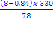 (1)

a= 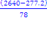

a = 30.3 m/s² (1)

b) Explain why launching from the air can allow for larger cargoes to be carried by Pegasus than similar sized ground based launchers.
(2 marks)
Less energy is required from the rocket because airplane motors have already increased the potential energy of the rocket.

c) When rockets are launched into space from the surface of the earth two of the factors considered are given below. For each factor explain why it is desirable or advantageous.

(i) They are launched in an easterly direction.
(1 mark)
Rotation of the earth contributes kinetic energy to assist rocket in escaping earth’s gravity so less energy is required by the motor.

(ii) The launching sites are as close to the equator as possible.
(1 mark)
The equator has a larger (rotational) velocity than the poles there for more rotational kinetic energy so less energy needs to be supplied by the motor

d) What velocity must Pegasus give a small satellite to put it in a circular Earth orbit at the height recommended by the OSC (Orbital Sciences Corporation)?
(Paragraph 8)
(3 marks)
h = 270 km = 270 000 m

r = 270 000 + 6.37 x 10⁶ = 6.64 x 10⁶ m

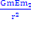 = v = 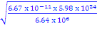

v = 7.75 x 10³ m/s orbit

Comment
Some people did not use the mass of the earth.

e) Explain what would happen to the orbit of the satellites after they ran out of fuel in seven years time? Why?
(2 marks)
Re-enter earth’s atmosphere and burn up

Friction with the earth’s atmosphere causes v ↓, which causes r ↓

∴ orbit decays and re-enters

f) (i) What is meant by a geostationary orbit?
(1 mark)
T = 24 hours or

Stays above the same spot on the planet
Comments
(not same speed)
(Yes same angular speed)
Yes same period

(ii) Why do these satellites need to be placed in orbits above the equator?
(1 mark)
So that the line of the orbit matches the line created when a continent rotates on the earth surface. This only occurs at the equator. Only continents on the equator rotate about the center of the earth like a satellite. Other counties off the equator rotate bout the earth’s axis but not about the center of the earth.
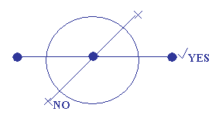

g) Why can’t satellites be launched into orbits at distances of less than 150km above the Earth?
(1 mark)
Atmosphere causes too much air resistance

h) The article states that communication satellites are in orbit 36 000 km above the equator. Verify this figure by using appropriate formulas.
(2 marks)
r = 4.237 x 10⁷

= → T = 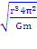

T = 8.476 x 10⁴s = 24.1 hours

Alternative solutions possible

i) If a 5.00 W transmitter sends a signal to the satellite positioned 270 km above, what is the intensity of the signal from the transmitter at the location of the satellite? Assume that the ground below the transmitter is a perfect reflector.
(3 marks)
I =

I = 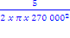

I = 1.09 x 10⁻¹¹ Wm⁻²
2.
Oceanographers make a noise to test the water
(20 marks)
(Paragraph 1)
An elaborate experiment to use sound waves to measure the temperature of all of the world’s oceans simultaneously is being planned by scientists from the US and Australia. They aim to determine whether the greenhouse effect has caused the temperatures of the oceans to rise as climate modelers predict.

(Paragraph 2)
The plan involves mounting a permanent sound source in the waters off Heard Island in the southern Indian Ocean. The scientists want to use the time it takes for sound to travel a known distance to determine the water’s average temperature. The time it takes to arrive – as much as three hours over thousands of kilometres – depends on the temperature and density of the water. If the oceans are warming, the density of the water will decrease and the sound will travel faster. “In effect, we will set up a global ocean thermometer,” says Walter Munk from the Scripps Institute of Oceanography, in La Jolla, California, where the technique is being pioneered.

(Paragraph 3)
A survey to determine exactly where off Heard Island the sound source should be located will begin next month as part of the maiden voyage of the Australian research vessel, Aurora Australis. In January next year, the researchers will hold a week-long feasibility study, involving acoustic receivers at 13 research stations on all of the continents (see Map).

(Paragraph 4)
If the study is successful, the team hopes to begin the full experiment, which will take 10 years to complete. Details of the experiment will be announced next week in Hobart by Andrew Frobe from the Australian research organization CSIRO’s Division of Oceanography. He will make the announcement at a meeting of the Australian and New Zealand Association for the Advancement of Science (ANZAAS).

(Paragraph 5)
According to some climate models, the world will become warmer within the next 30 years than at any other time over the past 200 000 years. Mean global temperatures could rise by almost 4°C. The models predict that the oceans will act as a “sink” for any increase in atmospheric heat. If this is correct, then the oceans should provide an accurate picture of global warming. The temperature of the sea may rise by as much as one-tenth of a degree every year, according to some models.

(Paragraph 6)
But oceanographers such as Munk, say that climate modelers do not yet have sufficient data to model the oceans accurately. The ocean acoustic experiment should yield more accurate information about the temperature of deep waters than other methods, such as remote sensing by satellite or readings from ships.

(Paragraph 7)
Sound in water is affected almost entirely by temperature and pressure; it is this phenomenon that the scientists are exploiting. A ‘sound channel’, where the speed of sound is at its minimum, exists at about one kilometre below the surface. This path is sandwiched between the warmer water above and the water below where the pressure is higher. These two channels allow sound to propagate at faster speeds. The depth of the channel depends on the temperature of the water – it is lower in warmer water near the equator and higher near the poles. The ‘axial depth’, or centre of the channel, occurs where the change in temperature becomes progressively smaller as the pressure continues to increase. The sound is refracted as it bounces between the water above and below the channel.

(Paragraph 8)
Munk became convinced that the experiment was possible after reworking data from an experiment carried out in 1960 off the west coast of Australia. Hydrophones about 16 000 kilometres away in Bermuda picked up a detonation of 130 kilograms of TNT at a depth of 1 kilometre. The researchers concluded that the sound followed a path called the Great Circle Route which is the shortest path between any two points on the globe.

(Paragraph 9)
Munk thought that the propagation of the sound would have been affected by the fact that the Earth is not a perfect sphere. Instead, the sound followed a geodesic path that was influenced by the colder water at higher latitudes. His calculations were an exact fit with the time the sound took to reach Bermuda.

(Paragraph 10)
By using this ‘refracted geodesic’ path, Munk and the others believe that it will be possible to transmit sound from Heard Island to numerous parts of the world’s five ocean basins – the North and South Atlantic, the North and South Pacific and the Indian Ocean.

(Paragraph 11)
The acoustic source to be used off Heard Island will transmit at a lower frequency – about 50 to 60 hertz – where there will be less interferences from ships and other sources of noise.

a) What is the principle behind setting up a global ocean thermometer?
(2 marks)
Speed of sound (2)

=

Comments
Time to travel a set distance = 1 marks only

b) On what two factors does the travel time of the sound depend?
(2 marks)
Temperature
Pressure
Not density

c) In the next thirty years it is feared that the mean global temperature could rise by almost 4°C. If this is correct why will the oceans provide an accurate picture of global warming?
(2 marks)
- The extra heat will be absorbed by the ocean (1)

- Large mass, produces accurate number (1)

d) What are the authors referring to when talking about sound channels?
(2 marks)
Slowest path (1)

Low temperature and low pressure (1)

e) What property of sound keeps the wave in the sound channel? A diagram may be useful in your explanation.
(2 marks)
Refraction (1)

Diagram (1)
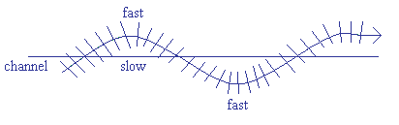
f) The acoustic source used off Heard Island is 57 Hz. For what reasons has this low frequency been selected?
(2 marks)
Few other sources of noise in the ocean have these frequencies

Sound diffracts better at low frequencies

g) If the average velocity of the sound wave in the sound channel is 1450 m s⁻¹, what is the wavelength of the wave?
(3 marks)
c = 𝛌 x f (1)

1450 = 𝛌 x 57 (1)

= = 2.54 x 10¹ m (1)

h) How long will it take for a pulse to travel from Heard Island to a receiver off Ascension Island some 9200 km away?
(3 marks)
v = (1)

t =

t = (1)

t = 6.34 x 10³ s (1)

Comments = SI units

i) It was found that the measured time was slightly greater than you calculated in h). Suggest a reason for the increase.
(2 marks)
Sound changes depth in a sinusoidal wave pattern and so travels a greater distance

(2)

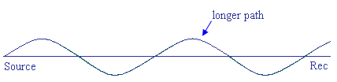

End Of Exam

References / Acknowledgements

www.antec.com – cooling fans (14/7/2009)

